Where the self-help helps…

Sanjay Jaju
Collector and District Magistrate
West Godavari District, Eluru, India < sjaju1@rediffmail.com >

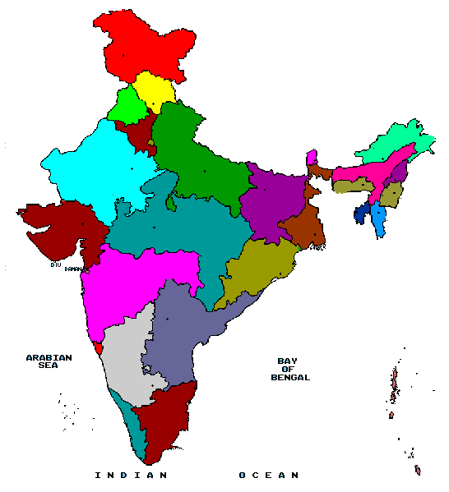
West Godavari
Fig.1 (West Godavari District, Andhra Pradesh (India)

Democracy, as we all learned in high school, has been defined as government of the people, for the people and by the people. While the first two goals have been to an extent met, the true test of democracy lies in it transitioning to being administered by the people themselves. Being the head of the district administration of the eSeva (e services) project, I had the opportunity of conceptualizing, implementing and sustaining an initiative wherein information and communications technology have acted as an agent in enabling such a change. We have helped to replace the traditional form of governance and its accompanying deficiencies with a modern, more open, transparent and responsive service delivery system.

eSeva began in the district West Godavari that falls in the province of Andhra Pradesh in India. The project is a tool to bridge the digital divide in the rural areas and has used Information Technology for providing access to various C2C (citizen-to-citizen) and C2G (citizen-to-government) services to the people living in rural areas. Under this project web enabled rural kiosks have been established in the villages. The unique thing about these centers is that they are run and managed by women’s self help (defined here as self-employment and economic empowerment) groups, and have been able to position the rural women as information leaders to help bridge the gender divide.

These centers run on a district portal that allows access to various citizen-centric services. These services range from the issuance of various certificates required for getting various social benefits to getting information about various programs and also go to the extent of networking citizens to each other and allow them the flexibility and convenience of mutually beneficial transactions. The horizontal portal is eventually put on the global World Wide Web and thus allows vertical integration with the expanding frontiers of universal knowledge and information. The project allows access to hitherto marginalized communities and therefore helps bridge the existing information gaps and is a step towards digital unite.

The computers in the village information kiosks are on a district wide network (a hybrid of dial up, 802.11 and WLL) helping kiosks interact with the district server hosting the local portal. To save on the networking cost, project has developed a unique synchronization tool that allows the kiosks to work offline and allows the databases to be periodically synchronized in minimal time. The project uses the opportunities that the information and communications technology offer in empowering the citizens and allows e-enabled education inputs to children to build their creative insights.

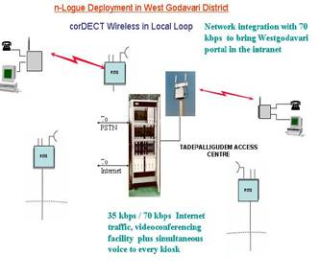



PHC
DM&HO
PHC
Esevas

Gatekeeper &
Gateway
Switch
E0
E1
APSWAN
Dist.
Offices
District
Data center
Dist. Offices
& Eseva centres
E-sevas
Dist. Offices
Dial-up
Dial-up
LAN
802.11b
Fig.2 WEST GODAVARI DISTRICT’S HYBRID NETWORK ARCHITECTURE

It would be meaningful to have a look at the growth of this project over a period of time. The broad dates are as below:

June ‘2002: A pilot ICT initiative to strengthen the self-help groups started in one block of this district.

Nov ‘2002: A comprehensive program to deliver civic services at rural points in convergence with self-employment schemes envisaged and conceptualized.

Jan ‘2003: The project eSeva in West Godavari district for providing access to various C2C (citizen-to-citizen) and C2G (citizen-to-government) services to the people living in rural areas through web enabled rural kiosks started in 46 places.

June ‘2003: The project getting evolved and institutionalized recording over 300000 transactions by this time.

Sept ‘2003: Partnership with Azim Premji Foundation forged to initiate model whereby children from the elementary government schools can daily come and learn at the centers through multi media CDs.

Nov ‘2003: 120 more centers added to the project fold, e-enabled education reaches to over 28000 students, transactions cross 600000.

July ‘2004: Centers connected through WLL, No of students taking e-enabled education increases to 70000, centres getting a bigger look and their own buildings

Oct ‘2004: No of Transactions cross 1.5 million, over 350 million rupees collected against electricity bills.

Nov ‘2004: e commerce activities for tribal tourism and lace park activities launched

Dec’2004: Telemedicine from specialists to the primary health centers started

Jan ‘2005: Transactions cross 2 millions, Project conferred the National Award for exemplary Implementation of eGovernance Initiative Year 2004 ("Gold Icon") under the Innovative Operations and Best Practices – Professional Category by the Government of India.

Feb ‘2005: A strategy titled ‘Closing School’ for intensively training graduate unemployed youth in computers, English and communication and other managerial skills for corporate placement launched.

The project has been developed using local knowledge, local content by local professionals. The development of the portal, operationalization of the applications and tools has been designed for local situations and network speeds. All the kiosks have in turn been handed over to women and youth self help groups. These individuals have also been trained and have shown remarkable improvement in their skills. The content on the citizen petitions is also in local language. Although roman alphabets are being used currently, steps are on to switch over to the local language fonts.
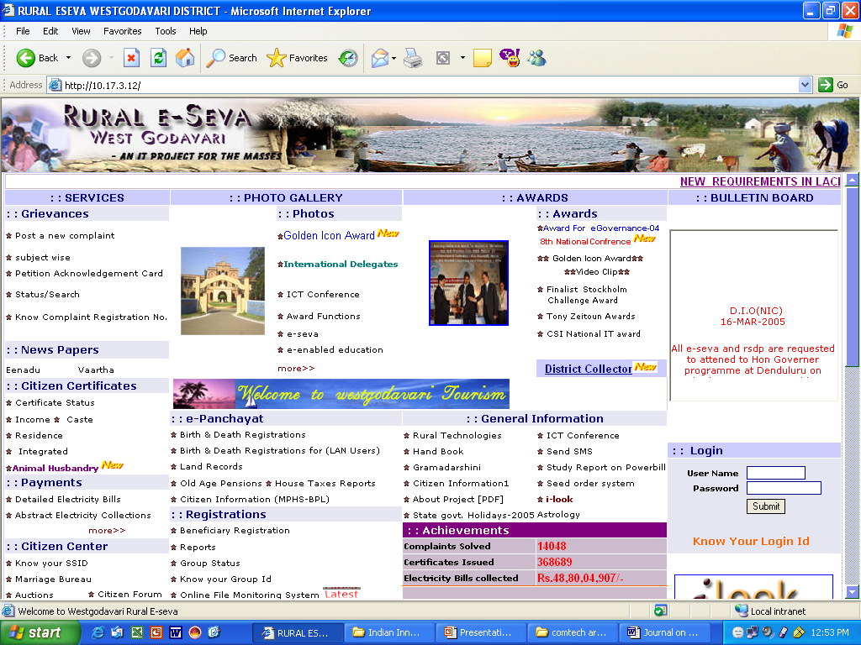
Fig.3
The District Portal
www.westgodavari.org/ - 2k - Cached - Similar pages

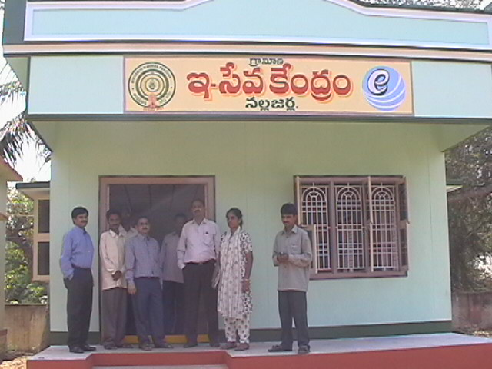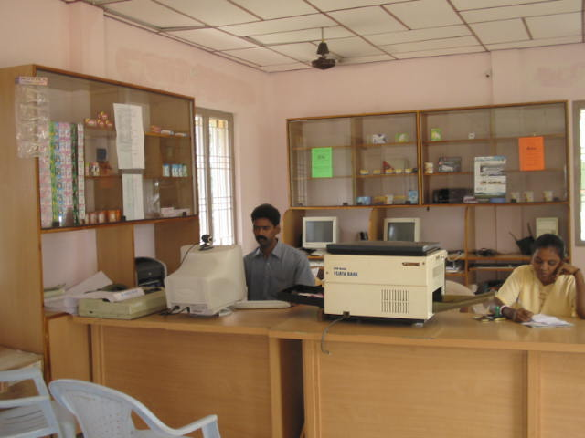
Fig.4 (eSeva centers- outside and inside)

The project offers host of services to the citizens living in the rural areas like

- Online filing of Complaints and grievances
- Online Application Registration for various government benefits
- Issuance of Certificates and Land Records
- Online Auctions and Biddings for rural marketing
- Payment of bills related to government departments
- Tele medicine
- Citizen Forums
- e-Education

The project authorities partnered with Azim Premji Foundation to reach out to the rural children for improving the quality of their education by joyful, exciting, interactive multimedia content for the enhanced learning levels. The project Kiosks are being used to transact this innovative activity.

This process of e-mpowering the citizens involve areas ranging from creating a conducive environment within the organization to stimulating positive responses outside. The challenge was to develop public awareness about IT and making the citizens use the medium created by the project for accessing civic services.

The project has had a tremendous impact in furthering the gender and digital unite. It has been able to buttress the women’s self help groups while it has been able to provide services to the citizens in hassle free manner as well. With over 200 kiosks in the district the project has completed more than 2 million transactions so far. An amount of over $98 millions have been collected as electricity bills without any hitch. All these centers are doing good business and are becoming self-sustainable. They are earning anything between $50 to $500 per month. Many of the centers are also adopting innovative methods of revenue generation. 14,000 different grievances from citizens pertaining to various problems have been redressed. The project has led to a citizen centric land records system resulting in evolution of a transparent and effective land record delivery system fully addressing the insecurities of the farmers. The project has also opened the possibility for the self-help groups to market their products directly without any middlemen to citizens horizontally within the district and vertically outside. The project portal is gaining from strength to strength and has large number of pages and databases related to the district and the citizens. The data pertaining to over 4 million citizens in varied form is available on the website. The website has also become a major dissemination and broadcasting tool for the various welfare programs. The project has helped in the creation of a knowledge and information economy thereby bringing in more opportunities and prosperity to the impoverished areas of this district. The project has also induced transparency in the implementation of the government programs and has facilitated weeding out ineligible cases so that corresponding benefits can be passed down to the needy.

As the project rural eSeva of West Godavari District crosses one milestone after another, it’s the time to do some stocktaking. The project is now 22 months old and it is roughly the time when the initial euphoria set of a project gives way to part-complacency and part-cynicism, and then begins a period of decline in its life cycle unless it is reversed by a proactive approach.

Statistics

January 2003 – March 2005
- Around 2 million transactions of citizen requests processed till March 2005.
- 68,500 Old Age Pensions Issued along with Identity card
- 3,59,790 Integrated Certificates Issued
- 770 House sites disputes solved
- 328 Bus shelter and timings issues resolved
- 945 Land disputes resolved
- 54,000 Ration card issues solved
- 13,906 specific citizen problems solved
- Over 10,000 e commerce activities for tourism, goods (SHG products), services (Insurance and small saving instruments etc)
- Matrimonial database contains over 12000 entries
- 16,73,933 transactions amounting over $98 millions of electricity dues collected.

The project has won the Gender ICT Award at the GKP Awards night at the World Summit on Information Society at Geneva in December 2003. It also captured the Tony Zeitoun Award in the ICT stories competition in the year 2003.

The project has also been nominated for the 2004 Stockholm Challenge Award in e-democracy category. The project has also won the first prize in the National Awards of the Computer Society of India in the year 2003. The project was also nominated in the World Summit Awards in year 2003, the only project in its category from India.

An evaluation of the project at this stage suggests the following findings:

- The project has proved that by combining the resources and energies locked in the urge of groups and individuals to pursue self-employment, a viable low cost alternative to bring in the benefits of information and communications technology can be created and sustained.
- The initiative has demonstrated that such projects can bring in transparency in the functioning of the administration to at least a plausible extent and allows an independent domain and space to the citizens to interact with government.
- Such a solution can not be restricted to only e-government but to a wide range of services that can bring additional returns to the operator and opportunities to the citizens to become part of the tech savvy globe.
- Such a transformation requires a strong will at the highest level to make such projects sail through the rough weather created by vested interests, pressure groups and entrenched lobbies.

The Project recognizes that no matter what the rhetoric is, real right to information is possible only if the information is put into the public domain and new technologies provide the most cost effective solutions for doing that.

Biographical Note

Mr Sanjay Jaju comes from India’s premier civil service, the Indian Administrative Service and has done a Post Graduate Programme in Project Design & Management from University of Manchester U.K. He has done his Masters in Thermal Engineering and is also a mechanical engineer. His areas of interest in this course were Environmental Science, Operations Research and Project Management. He is also a fellow from the Institute of Cost & Works Accountants of India.

During his job positions he has been an ardent advocate of Information technology for development. He is presently working as Collector & Dist. Magistrate, West Godavari in India,

In addition to the responsibility of looking after the administration in the district, he has pioneered a rural e-governance initiative called eSeva. During his previous stint as Municipal Commissioner, Visakhapatnam, in addition to the responsibilities of City management, a comprehensive facility “ Saukaryam” was initiated and completed to improve delivery of the civic services given by the Municipal corporation and has become a flagship project providing immense benefits to citizens. While working as the project director in a project for universalization of primary education in India, an IT project titled Headstart for computer-enabled education was initiated and completed by him. He has also worked as Project Officer in Integrated Tribal Development Agency inhabited by the most primitive tribal groups in the country, and took an IT initiative for building up the monitoring systems for the livelihood, education and health of the tribal people.

